**Project Proposal CITS5506: Internet of Things**

**Smart Cradle**

**1. Name of Project:**

Smart Cradle

**2. Group Number, Names and Student Numbers of team members:**

Group Number: Group 13

|  |  |
| --- | --- |
| **Name of Student** | **Student Numbers** |
| Zhulin Lyu | 24516605 |
| Meng Sun | 24002421 |
| YOUNG WEI | 23857911 |
| Riduan Rahman | 24607874 |

**3. Why do you want to do this project; What is the problem? What is the benefit of its solution? What is the impact of the solution?**

**3.1 Why do you want to do this project?**

In this rapidly developing world, infants are a beautiful and vulnerable existence, should be a top priority to preserve. Parents naturally want to ensure that their babies are safe, comfortable, and well-rested. However, long time babysitting can be both physically and emotionally exhausting. Lack of sleep, constant monitoring, and the anxiety of ensuring that their baby is safe can consume parents’ spirit. This is especially true in situations where sometimes a baby has suffocated or been trapped by things in their sleep environment, this is called a fatal sleeping accident. When no cause for the death can be found, it is called sudden infant death syndrome (SIDS) [1].

In 2020, 100 babies in Australia died of SUDI [1]. Research shows that sleep-related infant deaths, including those attributed to SIDS, remain a significant concern worldwide. The NICHD notes that SIDS is most common when an infant is between 1–4 months old. Additionally, more than 90% of SIDS deaths occur before the age of 6 months old [2].

With the "Smart Cradle", our goal is to use IoT technology into a cradle that can monitor a baby’s vital signs and sound environment in real time. By tracking these metrics, the cradle can alert parents to any emergency or risks, allowing for quick intervention when necessary. Additionally, the cradle can be manually controlled from our application—such as speaker or camera—based on the parents’ needs.

This project is driven by our goal to give parents peace of mind, knowing that their baby is being monitored and cared for even when they need to rest or step away, and create a safer, more supported environment for both infants and parents. That is a safe sleep environment to reduce the risk of all sleep-related deaths, such as avoidance of soft bedding and overheating [3].

**3.2 What is the problem?**

**Individual:**

* **Sleep-related Risks:** Infants are particularly accessible to sleep-related risks, including Sudden Infant Death Syndrome (SIDS), sleep apnea, and other health concerns that may go unnoticed during the night or when parents are not immediately present.
* **Parental Anxiety and Fatigue:** New parents often experience significant stress and fatigue due to the constant need to monitor their babies, leading to a potential impact on their own well-being and mental health.
* **Lack of Real-time Monitoring:** Traditional cradles do not provide real-time monitoring of an infant's vital signs, movement patterns, or sound, leaving parents with limited information to ensure their child's safety.
* **Electricity Safety:** Electricity situations can be very danger to baby's facilities, yet parents may not always be aware of these shifts or able to address them promptly.

**Society:**

* **Disparities in Infant Care:** Not all parents have access to advanced monitoring tools, high expenses leading to disparities in the quality of care that infants receive.
* **Work-life Balance:** The demands of constant monitoring can affect a parent's ability to balance work and personal life, leading to potential economic and social stressors.
* **Public Health Concerns:** Sleep-related newborn deaths remain a public health concern, and improving monitoring and care practices is critical to reducing these risks.

**3.3 What is the benefit of its solution?**

**Individual:**

* **Enhanced Infant Safety:** The Smart Cradle will provide real-time monitoring of vital signs, movement patterns, or sound, alerting parents to any potential risks and ensuring immediate intervention when necessary.
* **Reduced Parental Stress:** By automating the monitoring process, the Smart Cradle allows parents to babysit more easily, knowing that their baby is being watched over, which can lead to improved mental health and reduced tired.
* **Customized Care:** The cradle can manually be remotely controlled from our application—such as speaker or camera—based on the parents’ needs, promoting both parents and baby better sleep and overall well-being.
* **Peace of Mind:** Parents will benefit from knowing that their baby is safe and comfortable, allowing them to focus on other aspects of life and improve their overall quality of life.

**Society:**

* **Public Health Improvement:** By reducing the risks associated with infant sleep, The stability of the family can benefit society as a whole.
* **Social Benefits:** The Smart Cradle can help bridge the gap between poor and rich, providing more families with the affordable resources they need to care for their infants safely.
* **Promoting Technological Innovation:** The project showcases how technology can be used to solve real-world problems, inspiring further innovations in infant care and smart home solutions.
* **Supporting Work-life Balance:** By technological infant monitoring, parents can achieve a better work-life balance, contributing to overall societal well-being.

**3.4 What is the impact of the solution?**

* **Wide-reaching Impact:** The Smart Cradle has the potential to benefit millions of families worldwide. By providing a safer sleep environment, it can make a meaningful difference in the lives of countless infants and their parents.
* **Impact on Society Well-being:** The Smart Cradle directly impacts the mental and physical well-being of parents, particularly those who are experiencing the stress of caring for a newborn. By less problems of take care infants, may improve born rate of the whole society.
* **Economic Impact:** Potentially reducing healthcare costs associate with infant health issues. Additionally, the Smart Cradle can create new market and employment opportunities in the related fields.
* **Creating Market Value:** As a new technique, the Smart Cradle’s success can create the needs of modern families, who are increasingly looking for smart, connected solutions for their homes.
* **Promoting Social Harmony:** By addressing the challenges of parents and infants, the Smart Cradle promotes social harmony by reducing stress and fostering a sense of security and stability within families.

**4. What are the existing solutions? (Literature Review)**

When conducting a survey of smart cradles, it is necessary to explore various existing solutions to address the safety, comfort, and monitoring of infants. Here are some of the solutions explored by Smart Cradle technology:

* Real-Time Monitoring and Fall Prevention Through IoT Integration

Based on A Smart Baby Cradle Based on IoT [4], this paper discusses the development of a smart cradle that includes live monitoring through a web camera, addressing the problem of sudden death due to falling from the cradle. The proposed solution aims to enhance the safety of babies through IoT technology.

* Continuous Child Monitoring and Safety Enhancement via IoT (Joshi, 2017)

Based on Application of IoT in Different Aspects of Child Care: Literature Review and Classification [5], this review article classifies the different applications of IoT in child care, including innovations in smart cradles and cribs with external web cameras for continuous monitoring.

* Real-Time Infant Monitoring and Alerting with IoT Integration

Based on IoT-based Smart Baby Monitoring [6], this study proposes an IoT-based smart baby monitoring system that includes a webcam fixed in the cradle to provide real-time monitoring and alerting.

* Real-Time Emotion and Movement Monitoring for Hazard Prevention

Based on A Real-Time Internet Of Things (IoT) Based Affective Framework for Monitoring Emotions in Infants [7], this paper explores a real-time IoT-based system for monitoring infant emotions and movements, aiming to prevent potential hazards through smart cradle technology.

* Continuous Fall Prevention and Safety Monitoring via IoT

Based on IoT-BBMS: Internet of Things-based Baby Monitoring System for Smart Cradle [8], this paper presents a comprehensive IoT-based baby monitoring system designed to prevent falls and ensure the baby’s safety through continuous monitoring.

**5. How will you do it? Explain your methodology in a logical manner (step by step process). Draw a block diagram of the complete system. Explain design in terms of subsystems, their functionalities (software and Hardware) and their interdependence.**

* 1. **Diagram**

Block Diagram

Timing Diagram

* Pressure sensor timing diagram

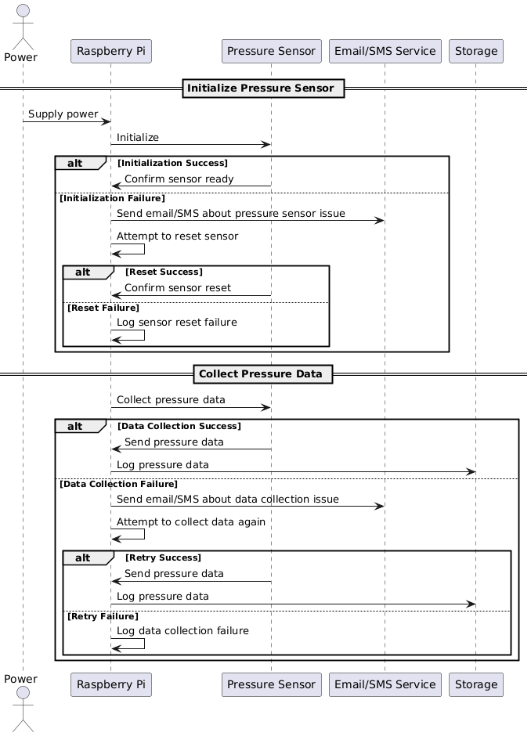

* Sound sensor timing diagram

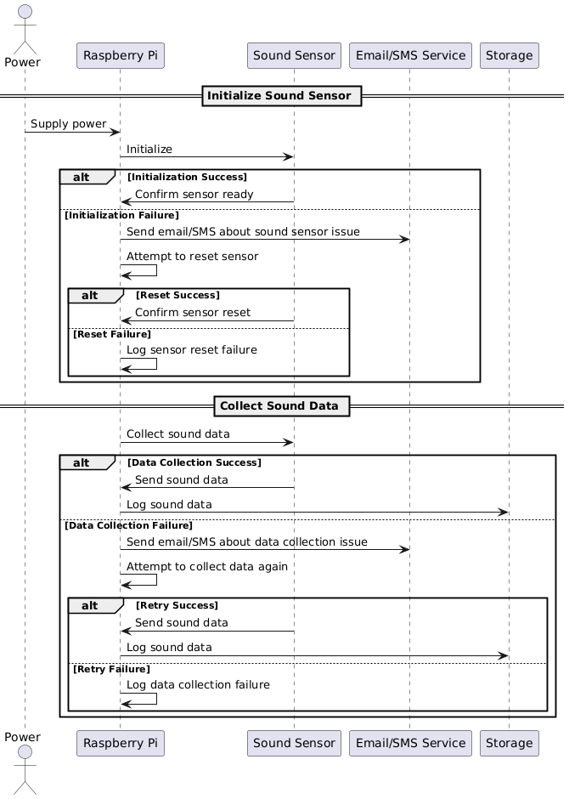

* Camera timing diagram

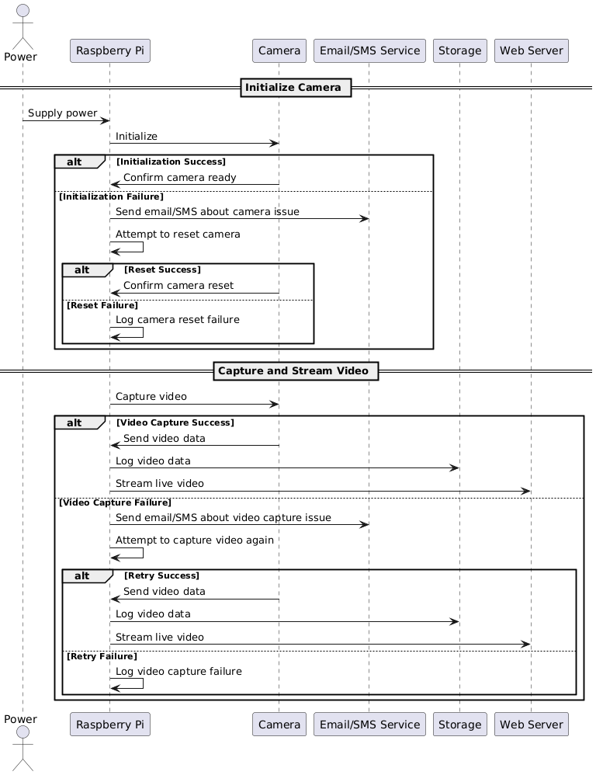

* Temperature sensor timing diagram

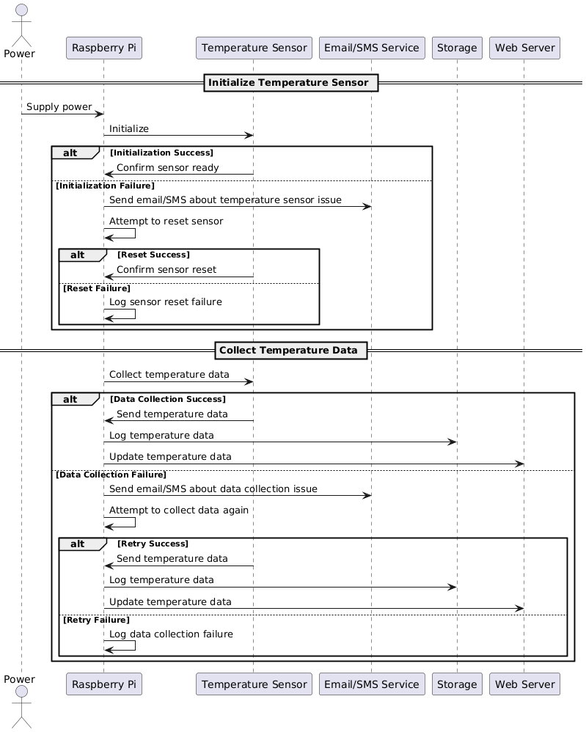

* UI Interaction

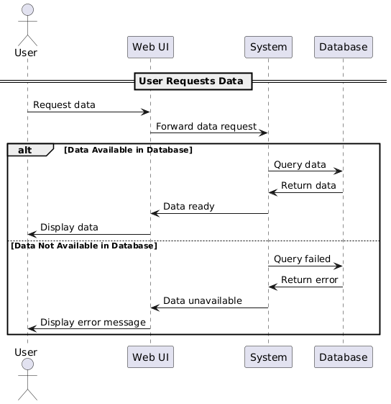

* 1. **Step-by-Step Methodology**

There are lots of subsystems for the project, and each system is responsible for the corresponding work. Therefore, it can be divided as two parts, hardware and software, coming along with their own functionalities:

1. **Sensor Subsystem (Hardware)**

* **Pressure Sensor**:

**Functionality**: For the pressure sensor, it consistently detects the weights of baby. There will be an alert, if the pressure sensor founds an unnormal changes of weight, which may means that baby was out of cradle or trying get out of cradle potentially.

**Interdependence**: It provides the current weights for Raspberry Pi as a processable resource.

• **Sound Sensor**:

**Functionality**: As for the sound sensor, it can detect the sound level to make a judgement of baby’s status. If the baby is crying or scream, there will be some works following the unnormal sounds , such as playing a soothing song, swinging the cradle, and sending a notification to the parents.

**Interdependence**: It provides the current sounds level for Raspberry Pi for the following solutions.

* **Camera Sensor (NoIR)**:

**Functionality**: In this part, the camera sensor will record how was baby doing. Also, it allows parents to watch the baby remotely via a web user interface.

**Interdependence**: Streams video data to the web interface via the Raspberry Pi.

* **Temperature Sensor:**

**Functionality**: In this part, the temperature sensor will record baby’s body temperature. Also, it allows parents to watch the baby’s body temperature remotely via a web user interface.

**Interdependence**: Data to the web interface via the Raspberry Pi.

2. **Power Supply Subsystem (Hardware)**

**Functionality**: Provides power to the entire system. Currently, there is no backup system, so the system relies on a stable power source.

**Interdependence**: Ensures that all subsystems remain operational.

3. **Processing Subsystem (Hardware/Software)**

* **Raspberry Pi**:

**Functionality**: Acts as the central processing unit, handling all sensor data, processing it, and making decisions based on the inputs. It also manages the web interface and alerts.

**Interdependence**: Collects data from all sensors, processes it, and interacts with the web server to provide a user interface and send notifications.

4. **Communication Subsystem (Hardware/Software)**

• **Wi-Fi Module**:

**Functionality**: Provides wireless connectivity, allowing the Raspberry Pi to communicate with the web server and send notifications via email or SMS.

**Interdependence**: Ensures that the system remains connected to the internet for real-time monitoring and notifications.

5. **Power-off Protection Subsystem (Hardware/Software)**

**Functionality**: When the network or power supply is unstable, email or SMS notifications is sent out in time through heartbeat signal and voltage monitoring, and local storage is used to ensure that information is not lost when the network is disconnected.

**Interdependence**: Connectivity and monitoring interdependence--wireless connectivity and monitoring functions are closely integrated to ensure real-time communication and alarm. Local storage and data integrity are interdependent.

6. **Alert and Notification Subsystem (Software)**

• **Email/SMS Notifications**:

**Functionality**: It will send alerts to parents, if there is something not well such as when baby is crying, screaming.

**Interdependence**: Receives triggers from the Raspberry Pi based on sensor data.

7. **Data Logging and Monitoring Subsystem (Software)**

**Functionality**: Logs sensor data, including video, sound levels, and movement data, for analysis and review.

**Interdependence**: Works with the Raspberry Pi to store data locally or in the cloud, accessible through the web interface.

8. **User Interface Subsystem (Software)**

• **Web Interface**:

**Front End**: Built using HTML, CSS, and JavaScript, this interface allows parents to monitor the baby in real-time and check daily data of infant from the dashboard.

**Back End**: Developed using Flask, the back end handles data processing, communication with the Raspberry Pi, and managing the database.

**Interdependence**: Provides a portal for parents to interact with the system, view live video, and receive notifications.

**6. As sub teams are made, and project divided into tasks for sub teams then write initial distribution of work among students by mutual discussion (as per strengths of the members). You may change it during the project.**

|  |  |  |
| --- | --- | --- |
| **Name of Student** | **Work Assigned** | **Reason for the Assignment** |
| Zhulin | **Hardware Integration and Sensor Control**   * Responsible for connecting and configuring the Raspberry Pi with various sensors (ultrasound, sound, camera). * Realize sensor data acquisition function. * Integrate Wi-Fi module and email module. * Develop basic code for real-time monitoring of sensor data. * Responsible for the project documentation writing of the hardware and sensor part | Developer has basic experience in configuring and using the Raspberry Pi and can use Python programming skills to write control programs on the Raspberry Pi. |
| Meng | **Software Development and Data Processing**   * Develop the main control program running on the Raspberry Pi to coordinate the data collection of various sensors. * Implement the baby crying detection algorithm and trigger the playing of sleep music. * Responsible for transmitting sensor data to the database and interacting with the database. * Implement the email notification function. * Responsible for the project documentation writing of the software development and data processing part | Developer has basic experience in Python programming and can develop a sound detection algorithm to ensure that the sound is received and processed correctly. The developer has experience in database and Linux operations and can configure the software environment on the Raspberry Pi and write code to interact with the database. |
| Young | **Web front-end development and design**   * Responsible for designing and developing the interface of the Web dashboard. * Ensure real-time display of sensor data and provide historical data query function. * Implement user-friendly interactive design to ensure the system is easy to use. * Work closely with back-end developers to ensure seamless integration of front-end and back-end. * Responsible for the project documentation writing of the front-end development and design part | Developer has extensive front-end development knowledge, is proficient in HTML, CSS, and JavaScript, has experience with front-end data visualization tools, and can design intuitive and easy-to-use dashboard interfaces. |
| Riduan | **Backend development and database management**   * Responsible for designing and developing databases for storing and querying sensor data. * Develop the backend service of the Web dashboard, responsible for processing data requests and providing API interfaces. * Ensure stable and efficient data transmission between the database and the Raspberry Pi. * Implement data security and backup solutions. * Responsible for the project documentation writing of the backend development and database management part | Developer is familiar with database management systems, can design and manage databases, is proficient in back-end development languages, and can develop and maintain web services. Additionally, the developer has knowledge of data security and backup, ensuring data integrity and security. |

**7. A well-defined timeline related to subsystems should be made. Tasks should be assigned to sub-teams (refer above 8) and Timeline should cater for interdependence (parallel or sequential) of the subsystems.**

|  |  |
| --- | --- |
| **Timeline** | **Work Assigned** |
| 26 August – 08 September | **Overall design of each unit module**   * The hardware developer purchases and configures the Raspberry Pi and various sensors and integrates the Wi-Fi module. * The software developer designs the system architecture and develops basic program algorithms. * The front-end developer designs the interface prototype for the web dashboard. * The back-end developer designs the database structures and builds basic back-end services. |
| 09 September – 22 September | **Function development of each unit module**   * Hardware developer complete sensor data collection and hardware debugging to ensure the stability of hardware operation and to collect the required data. * Software developer implement sound detection and sleep music playback functions, develop code that interacts with the database, and ensure that the collected information can be stored in the database. * Front-end developer complete dashboard development to achieve data visualization, historical data search, user permission login and other functions. * Back-end developer complete database construction and API development to ensure normal storage and reading of data. |
| 23 September – 06 October | **Integration and testing**  Complete the integration test of sensors, main control program, front-end interface and back-end database interface to ensure functional accuracy, real-time and availability, and stable data transmission. |
| 07 October – 20 October | **Project closing and optimization**   * Perform full system testing and fix any bugs or issues. * Prepare project documentation and final report for delivery. |

**8. Hardware required (Each group has $50 budget for the items (not including cost of items and sensors available at UWA). Due to delivery time consideration, you should choose items from Jaycar and Altronics. Consult Andy our Lab Technician (Email** [**andrew.burrell@uwa.edu.au**](mailto:andrew.burrell@uwa.edu.au)**), as there could be alternate items already at UWA, thus saving the delivery time.**

|  |  |  |  |  |
| --- | --- | --- | --- | --- |
| **No.** | **Items Description** | **Available at UWA**  **(Yes/No)** | **Amount** | **Web** |
| 1 | Jumper wires | Yes | Multiple | https://core-electronics.com.au/premium-female-male-extension-jumper-wires-20-x-12.html |
| 2 | LED | Yes | Multiple |  |
| 3 | Resistor(220R,10K) | Yes | Multiple |  |
| 4 | MicroSD Memory Card - 16GB Class 10 | Yes | 1 |  |
| 5 | Load Cell Mounting Kit | Yes | 1 |  |
| 6 | Leaving detection( Sound sensor )-ultrasonic /  makerverse load amplifier | Yes | 1 |  |
| 7 | Sound sensors - Arduino  compatible sensor | Yes | 1 |  |
| 8 | Camera sensors - NolR | Yes | 1 |  |
| 9 | Temperature Sensor - Non Contact | Yes | 1 |  |
| 10 | Electrical leakage -Watt  meter | Yes | 1 |  |
| 11 | Raspberry Pi | Yes | 1 |  |
| 12 | Pushbutton | Yes | 1 |  |
| 13 | ProjectBox | Yes | 1 |  |
| 14 | 5VDC PowerSupply | Yes | 1 |  |
| 15 | 1 Channel SPDT Relay Module | Yes | 1 |  |
| 16 | USB Cable | Yes | 1 |  |
| 17 | Speaker | Yes | 1 |  |
| 18 | Breadboard | Yes | 1 |  |
| 19 | Load Cell Amp | Yes | 1 |  |
| 20 | Load Cell Screws | Yes | 1 |  |
| 21 | Load Cell 1Kg | Yes | 1 |  |

**9. References**

[1] Health Direct. (2022). Sudden infant death syndrome (SIDS). Available: https://www.healthdirect.gov.au/sudden-infant-death-syndrome-sids. [Accessed 23 August 2024].

[2] Medical News Today. (2022). "What is the risk of sudden infant death syndrome (SIDS) based on age?". Available: https://www.medicalnewstoday.com/articles/sids-risk-by-age#risk-factors. [Accessed 23 August 2024].

[3] American Academy of Pediatrics. (2022). Evidence Base for 2022 Updated Recommendations for a Safe Infant Sleeping Environment to Reduce the Risk of Sleep-Related Infant Deaths. Available: https://publications.aap.org/pediatrics/article/150/1/e2022057991/188305/Evidence-Base-for-2022-Updated-Recommendations-for?autologincheck=redirected. [Accessed 23 August 2024].

[4] Alshewani, S. A., & Eassa, F. E. (2020). A Smart Baby Cradle Based on IoT. Available: https://www.academia.edu/download/63998973/V9I7202018.pdf. [Accessed 24 August 2024].

[5] Boruah, K., & Pathak, M. K. (2021). Application of IoT in Different Aspects of Child Care: Literature Review and Classification. Available: https://www.researchgate.net/profile/Kuntala-Boruah/publication/354123249_Application_of_IoT_in_Different_Aspects_of_Child_Care_Literature_Review_and_Classification/links/6267c583ee24725b3ec7f44d/Application-of-IoT-in-Different-Aspects-of-Child-Care-Literature-Review-and-Classification.pdf. [Accessed 24 August 2024].

[6] C, V. a. (2021). IoT based Smart Baby Monitoring. 2021 Second International Conference on Electronics and Sustainable Communication Systems (ICESC), 1-6.

[7] Chauhan, H. a. (2021). A Smart Cradle System to Monitor Infants for Healthcare Baby Wards Based on IoT and Blockchain. 2021 3rd International Conference on Advances in Computing, Communication Control and Networking (ICAC3N), 606-609.

[8] Hotur, V. P. (2021). Internet of Things-based Baby Monitoring System for Smart Cradle. 2021 International Conference on Design Innovations for 3Cs Compute Communicate Control (ICDI3C), 265-270.

[9] Jabbar, W. A. (2019). IoT-BBMS: Internet of Things-Based Baby Monitoring System for Smart Cradle. IEEE Access, 93791-93805.

[10] Joshi, M. P. (2017). 2017 International Conference on Computing, Communication, Control and Automation (ICCUBEA). IoT Based Smart Cradle System with an Android App for Baby Monitoring, 1-4.

[11] Kavitha, S. a. (2019). Analysis on IoT Based Smart Cradle System with an Android Application for Baby Monitoring. 2019 1st International Conference on Advanced Technologies in Intelligent Control, Environment, Computing & Communication Engineering (ICATIECE), 136-139.

[12] Patil, A. R. (2018). Smart Baby cradle. 2018 International Conference on Smart City and Emerging Technology (ICSCET), 1-5.

[13] Pratap, N. L. (2021). IoT based Smart Cradle for Baby Monitoring System. 2021 6th International Conference on Inventive Computation Technologies (ICICT), 1298-1303.

[14] Sallah, A. a. (2020). Tot-Mon: A Real-Time Internet of Things Based Affective Framework for Monitoring Infants. 2020 IEEE Computer Society Annual Symposium on VLSI (ISVLSI), 600-601.

[15] Saude, N. a. (2020). IoT based Smart Baby Cradle System using Raspberry Pi B+. 2020 International Conference on Smart Innovations in Design, Environment, Management, Planning and Computing (ICSIDEMPC), 273-278.